If you know excel may be you can help me. If you undertand this doc, go ahead and try it. thanks!!

Take a look in column F on Sheet Main!.
If you see a link it means I know the source, and we need to prep te data.

1.-Download the data. Get the data into excel.
Note there is a bug in the World bank webpage. If you can´t download the data, use the link for XML and change the last word “XML” and put “EXCEL”.

2.- Remove the columns of the years to leave only 1995 to 2011

3.-Create a new sheet and paste the Country list (you can copy paste from any GDocs already there).

4.-Do this layout:
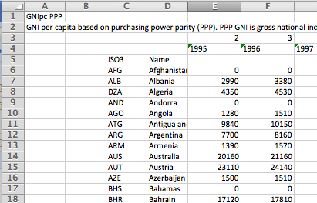
A1 is title
A2 is explanation/source
C5 is ISO3 code. Rest is the chunk of countries.
E4 start the years array till 2011
E3 is an array with 2,3,4... (you´ll use it for the vlookup)

5.-E5 is: =VLOOKUP($C6;Sheet1!$C$7:$T$257;E$3;FALSE)

This looks up the Value in C6 (AFG) in the array of the data (on Sheet1 area $C$7:$T$257 ) . On the line it finds AFG, it takes the E3 (2nd) value. That is the corresponding for 1995. Make sure is the right one.

6.-Pull the little dot in the lower right corner to autocomplete the whole line 6 (AFG).
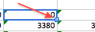
The dollar sign on the formula is to tell excel not to correlate the reference. So it always takes the Country column, but it takes the appropiate column of the year.

7.-Autocomplete the whole sheet.

8.- Copy all the data. Make a new Sheet and click “Paste Special” then “values”. It will paste the values.

9.-Upload to Gdocs and add the link into the Main Sheet of 0.6 on Column O.

In the end it should look like the first sheet of this one:
https://spreadsheets5.google.com/spreadsheet/ccc?hl=en_US&key=txLM3ghGtxPjuI2sL6n8xcA&hl=en_US#gid=0

10.-I you got here, I´ll pay you a beer for any link to such a Google Doc you make :)
Tell me so I update the list.

